H.T No
Regulations:
A15

Sreenidhi Institute of Science and Technology
(An Autonomous Institution)
Code No: 5AC07 Date: 18-Nov-2020 (FN)

B.Tech II-Year II-Semester External Examination, Nov/Dec - 2020 (Supplementary)
CONTROL SYSTEMS (EEE)

Time: 2 Hours Max.Marks:75

Note: a) No additional answer sheets will be provided.
b) All sub-parts of a question must be answered at one place only, otherwise it will not be valued.
c) Missing data can be assumed suitably.

ANSWER ANY 5 OUT OF 8 QUESTIONS. EACH QUESTION CARRIES 15 MARKS.

1. | a) | Give two real time examples of open loop and closed loop control systems. | [8M]
 | b) | Differentiate the signal flow graph and block diagram methods for finding transfer function of a system with an example. | [7M]
2. | a) | The unity feedback control system is characterized by an open loop transfer function 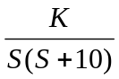 Determine gain K, so that the system will have damping ratio of 0.5. Determine peak overshoot and peak time for a unit step input. | [8M]
 | b) | Explain steady state error for various types of inputs. Find the steady state error with unity feedback system given by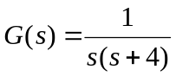 for the input 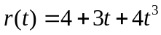. | [7M]
3. | a) | Describe about Stability, conditional stability and relative stability. | [8M]
 | b) | Using Routh-Hurwitz criterion check whether systems represented by the following characteristic equation are stable or not. Comment on the location of roots. Determine the frequency of sustained oscillations if any  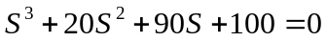 | [7M]
4. | a) | Explain the following Frequency Domain specifications:  i) Phase Margin ii) Gain Margin  iii)Phase cross over frequency iv)Gain cross over frequency. | [8M]
 | b) | Sketch the bode plot of the system 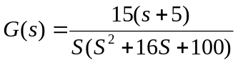. Determine the stability of the system. | [7M]
5. | a) | Sketch the polar plot of the system represented by following open loop transfer function.  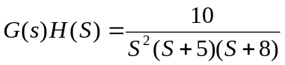 | [8M]
 | b) | Deduce the expressions for transfer functions of lag, lead and lag-lead compensators. | [7M]
6. | a) | Explain the importance of i) controllability and observability ii) state transition matrix iii) diagonalization of the control system model in the design of the control system. | [8M]
 | b) | Write the importance of state space model, Explain four properties of state transition matrix. | [7M]
7. | a) | Find the transfer function of the following block diagram  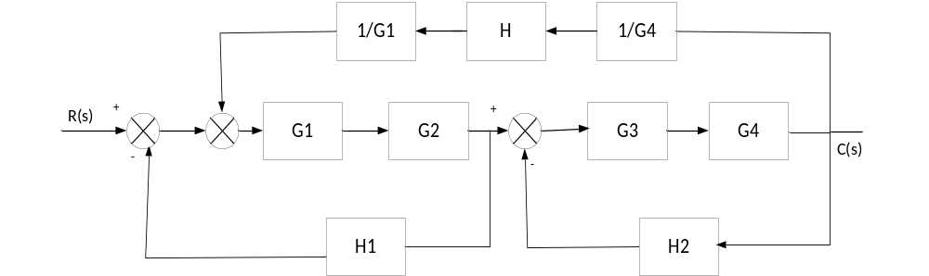 | [8M]
 | b) | Explain Mason’s gain formula to find transfer function of a signal flow graph. Determine the transfer function of the following signal flow graph.  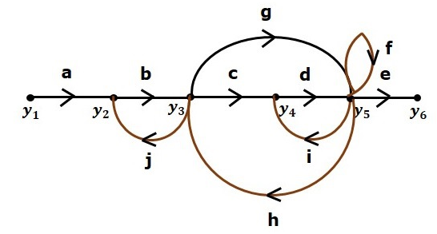 | [7M]
8. | a) | Find the delay time, rise time, peak time, settling time and peak overshoot for unity feedback system with open loop transfer function.  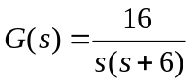 | [8M]
 | b) | Write short notes on PID controllers. | [7M]

-- 00 -- 00 –

